**Release 2 Acceptance Tests**

The following acceptance tests will provide screenshots and descriptions of how each user story aligns with the associated acceptance criteria.

**Story 12:** **Health and Safety Notifications**

This story fulfils the acceptance criteria as admins can mark issues as resolved and delete invalid reports. They are also notified when each issue is successfully filed and can click on the report ID for more information.

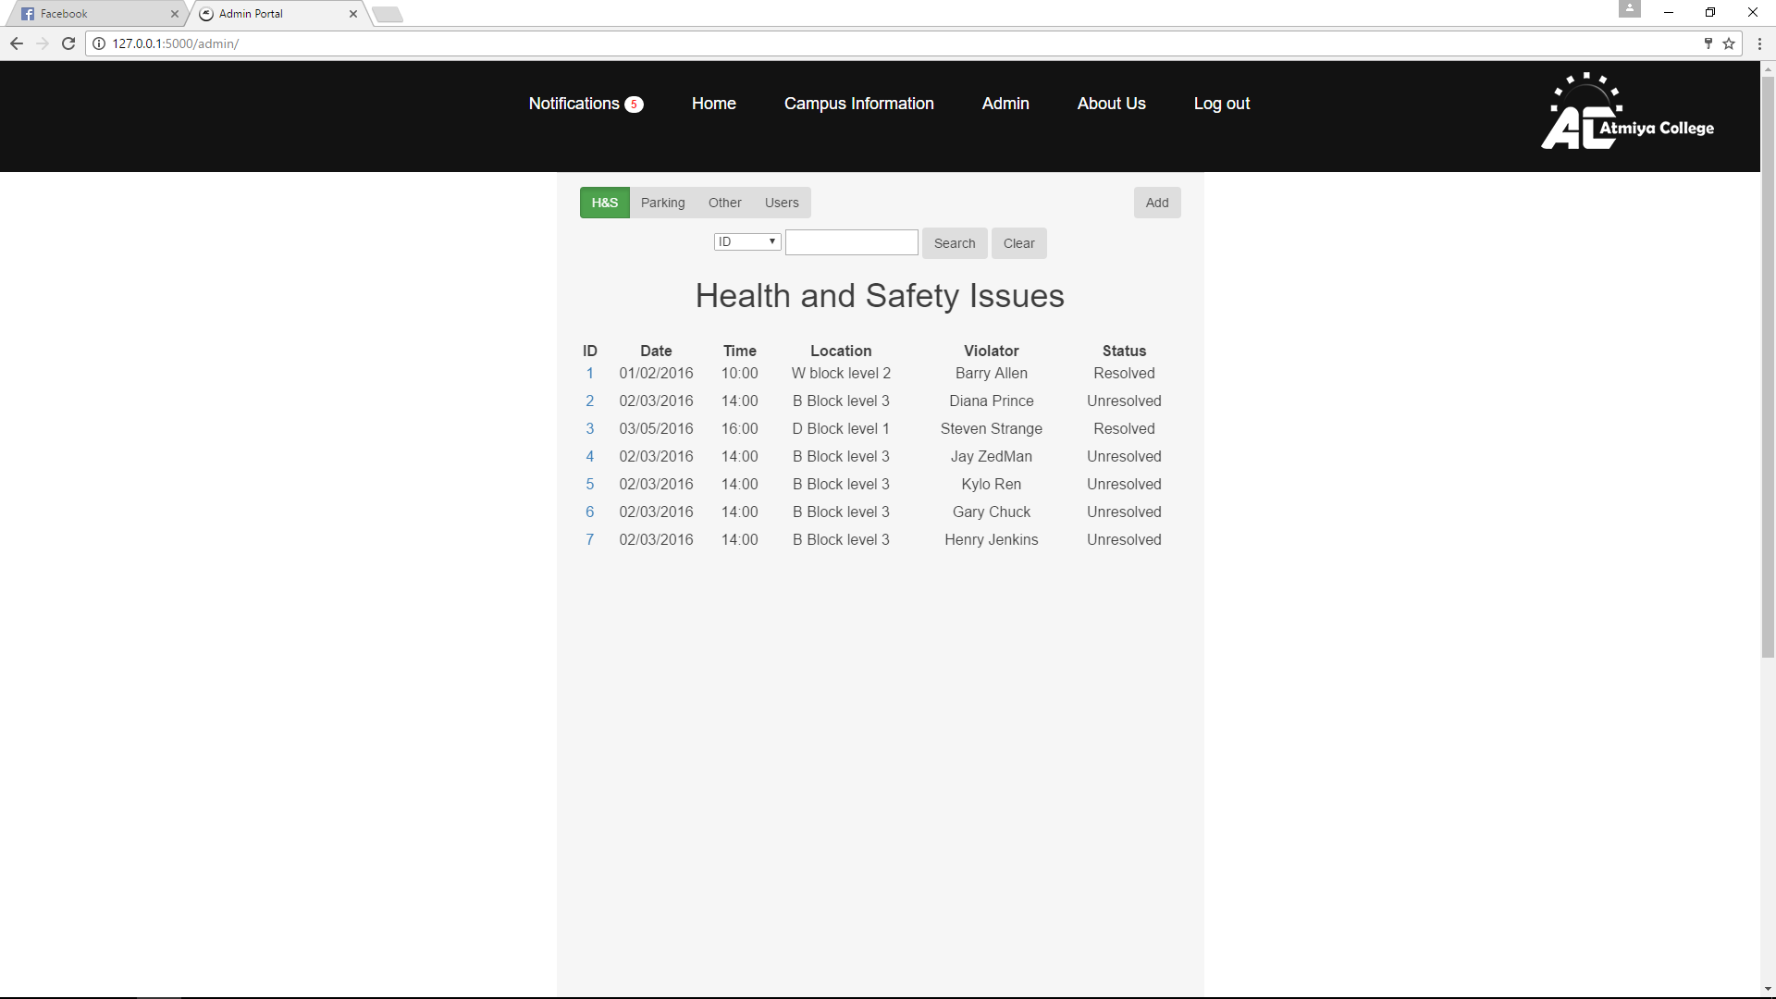

**Story 6: Parking Violation**

Acceptance criteria has been met because parking officers can sort parking and other issues by criteria.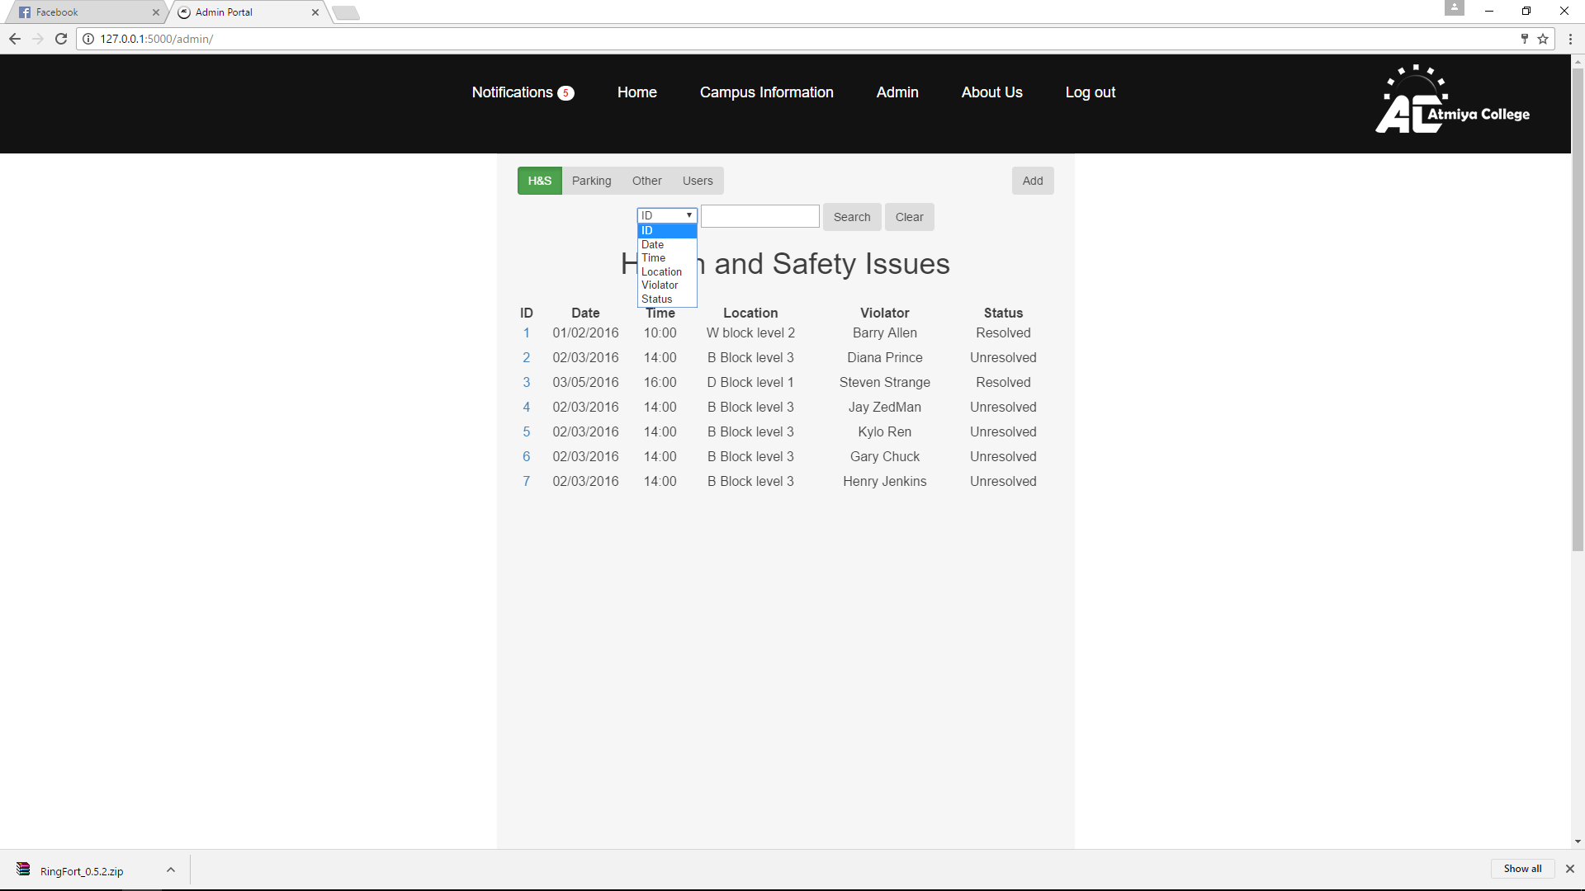

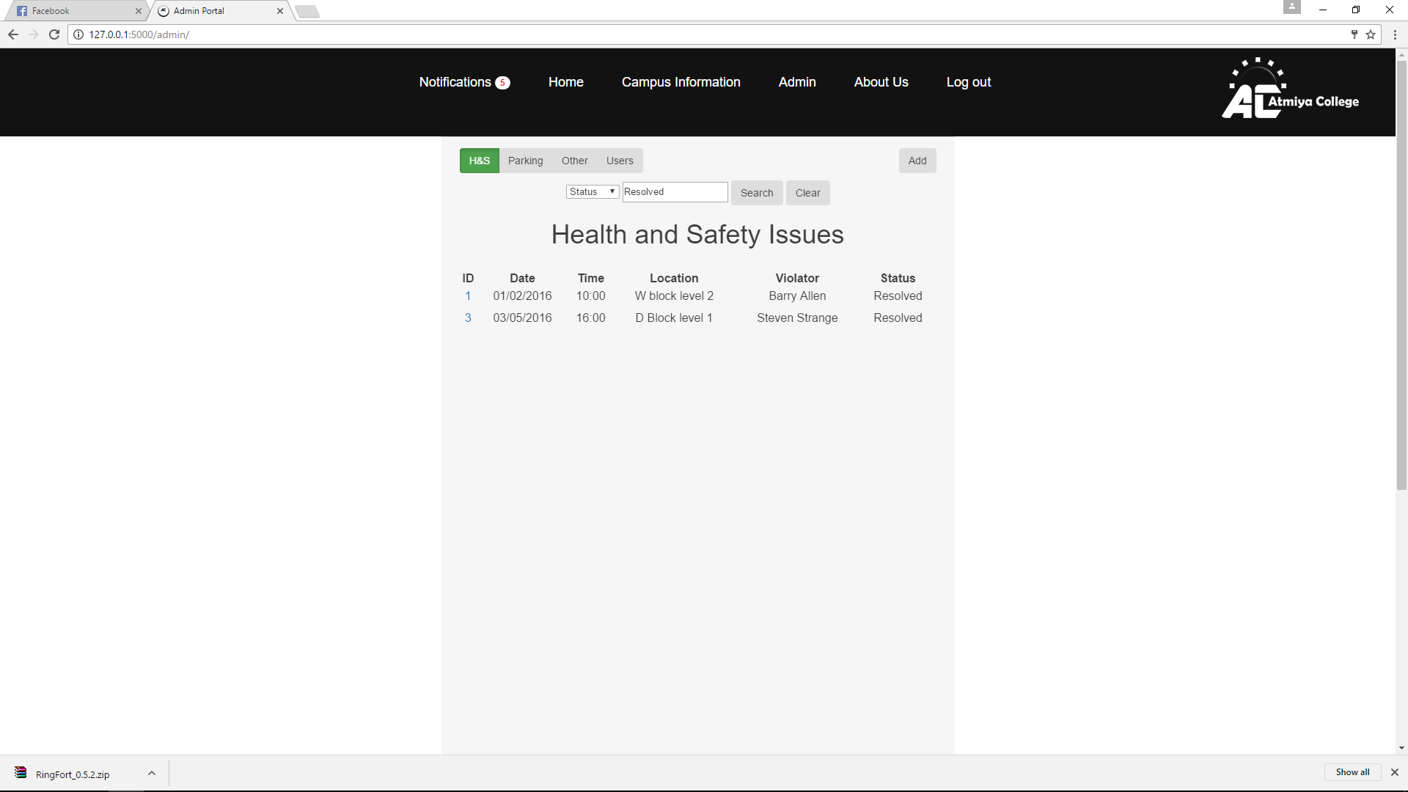

* User Searches for resolved health and safety issues

**Story 22: Error Correction**

Acceptance criteria is complete as admins have special access to check, sort and view permits or violations in two separate lists.

**Story 23: Administrative Management**

Acceptance criteria is fulfilled because administrators can distinguish the account type and can use sorting criteria (e.g. ID, name, email account type).

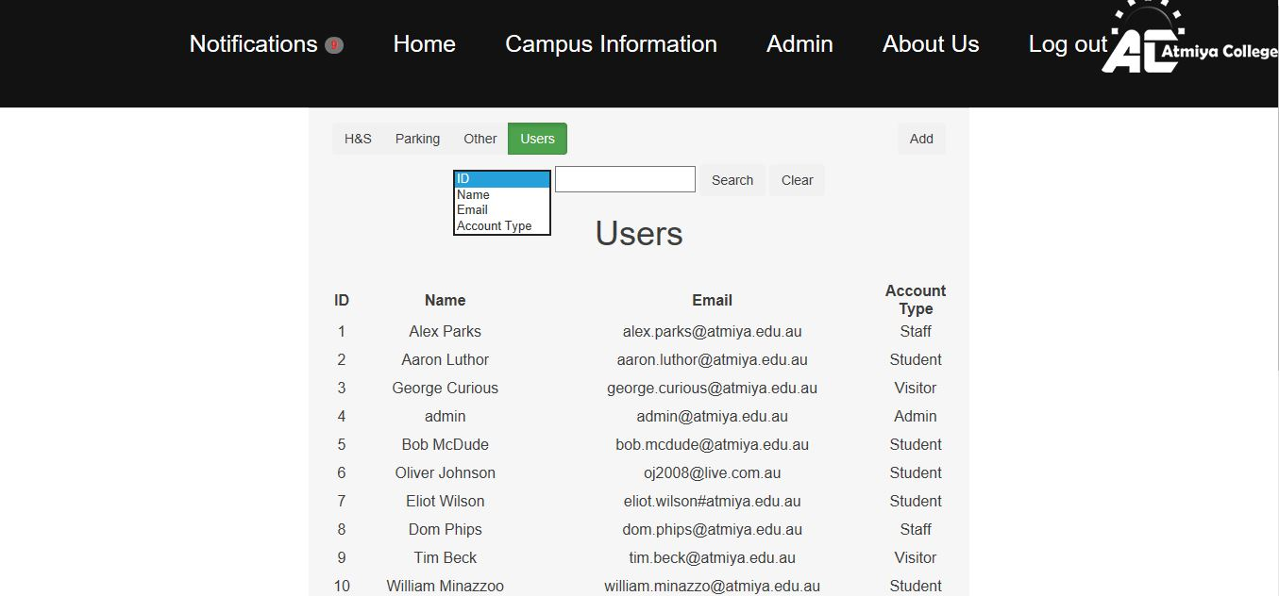

**Story 28: Review Overdue Fines**

System administrators can readily review overdue violation payments as they appear in red. Once the fine is payed the violation is marked as resolved and becomes un-flagged.

**Story 9: Fine Payment Checking**

By clicking on the overdue status of violation and sends an email notification to the user, this story therefore exceeds the acceptance criteria as it supports both an automated and manual response from the server.

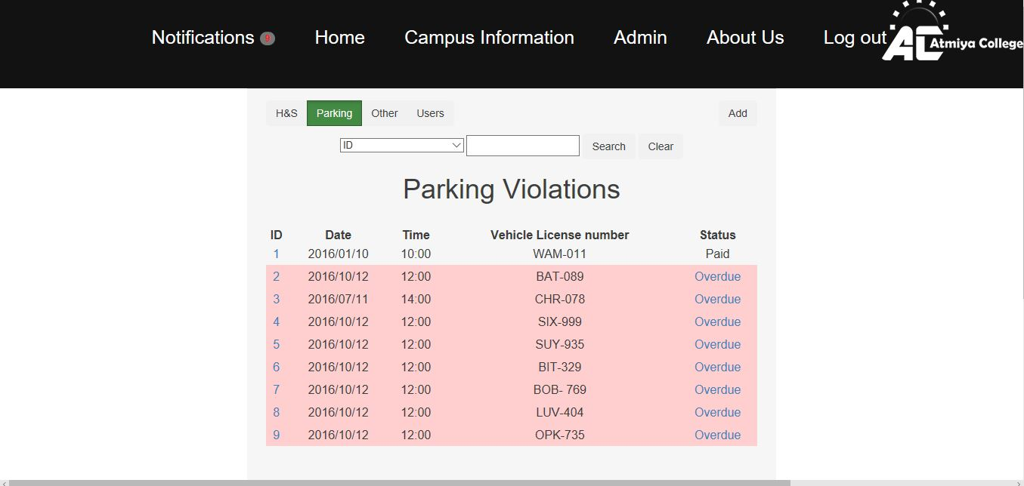

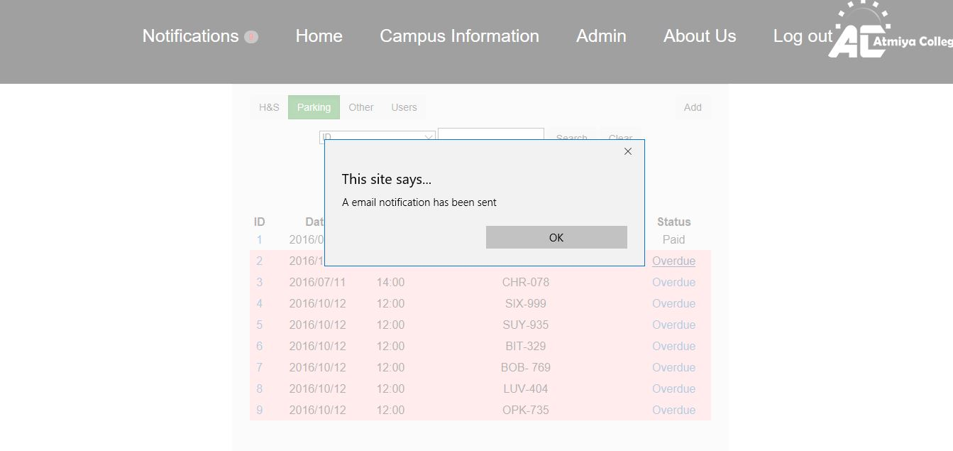

*Above screenshot shows when the overdue status is clicked, an email is sent.

**Story 11: Simple Payment forms**

The acceptance criteria for this story is fulfilled because a user/student (in this case Aaron Luthor) has a payment gateway (in the form of “Pay Fine” button) in their profile next to violation that links straight to the payment webpage.

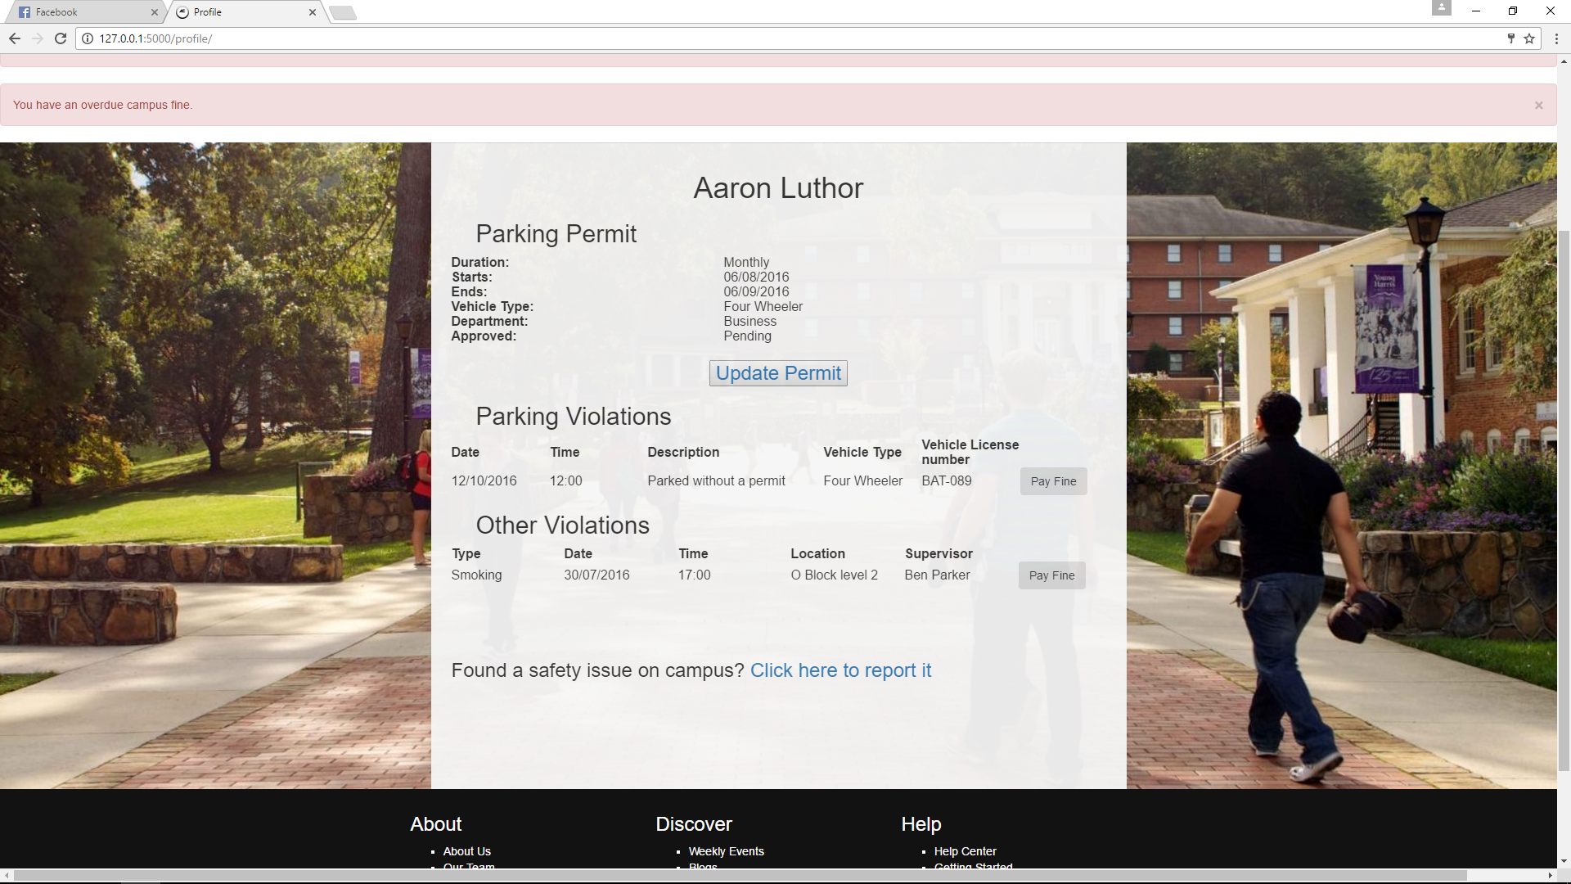

**Story 5 Parking Permit Payment**

Acceptance is fulfilled because you can choose payment options including Visa and MasterCard, the user can enter in all their appropriate details to complete the payment.

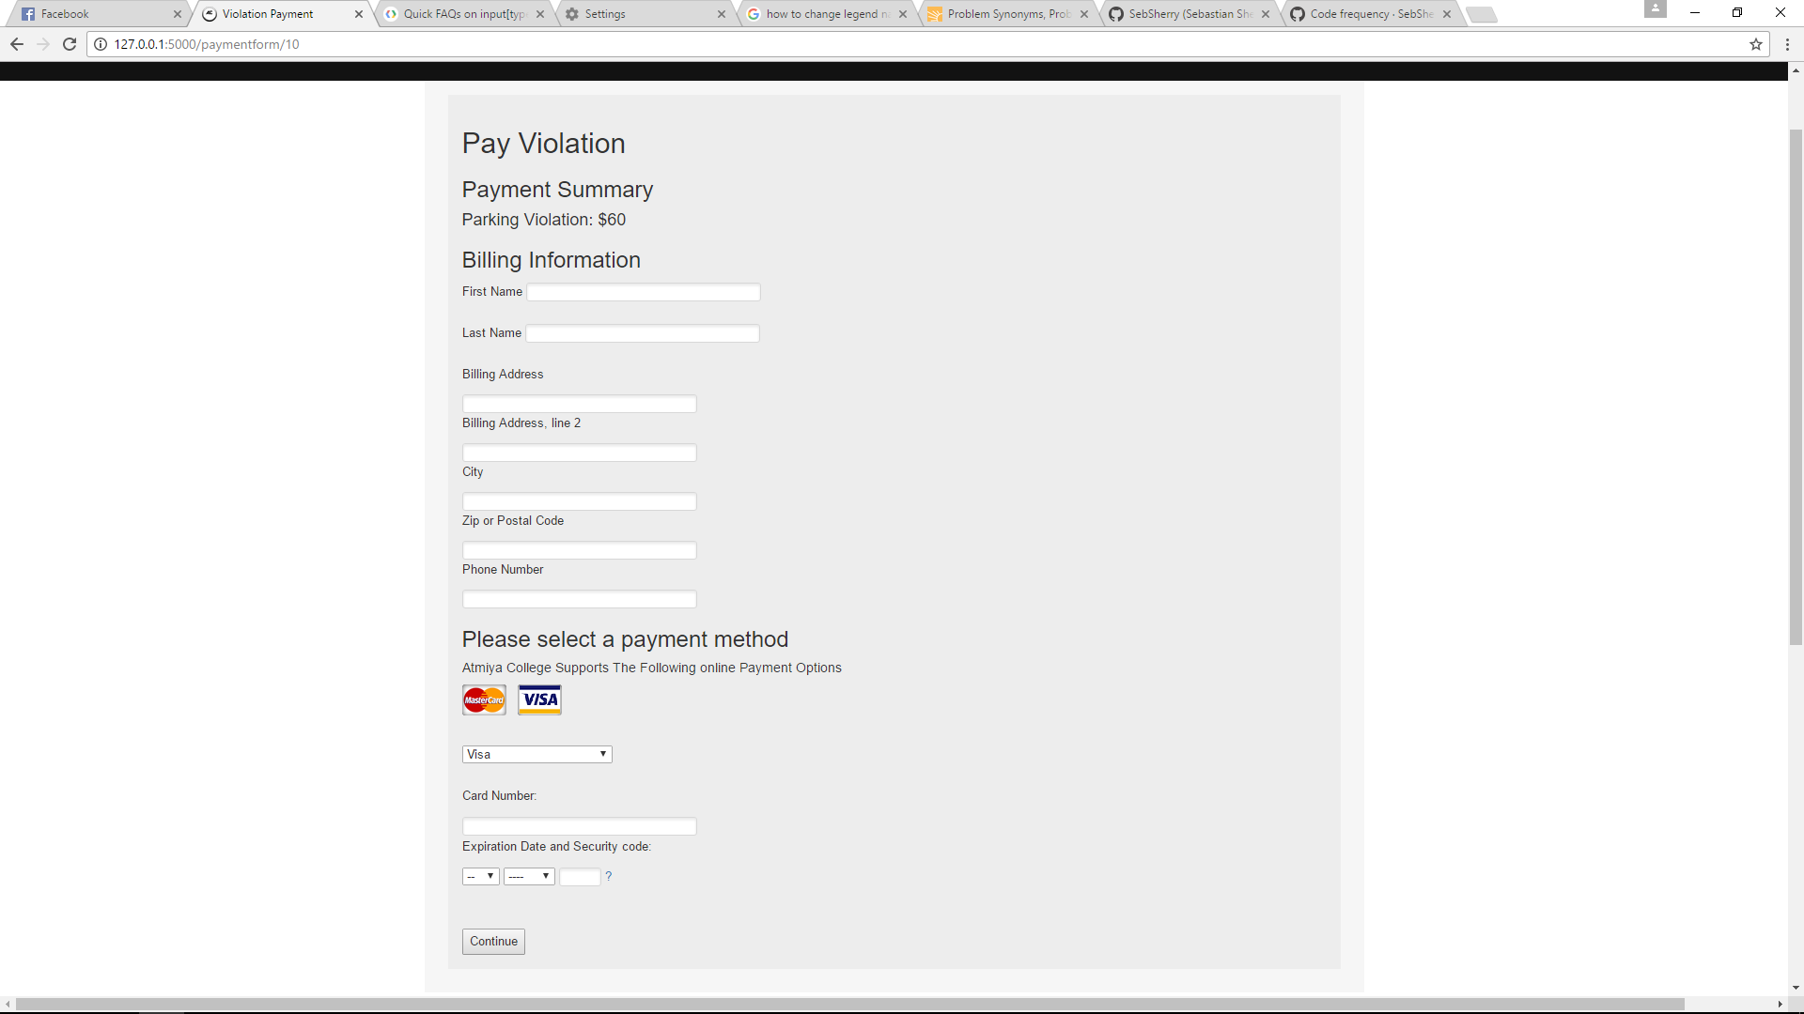

**Story 25: Generic Updates**

As described in the acceptance criteria, generic notification updates are given upon login as a user.

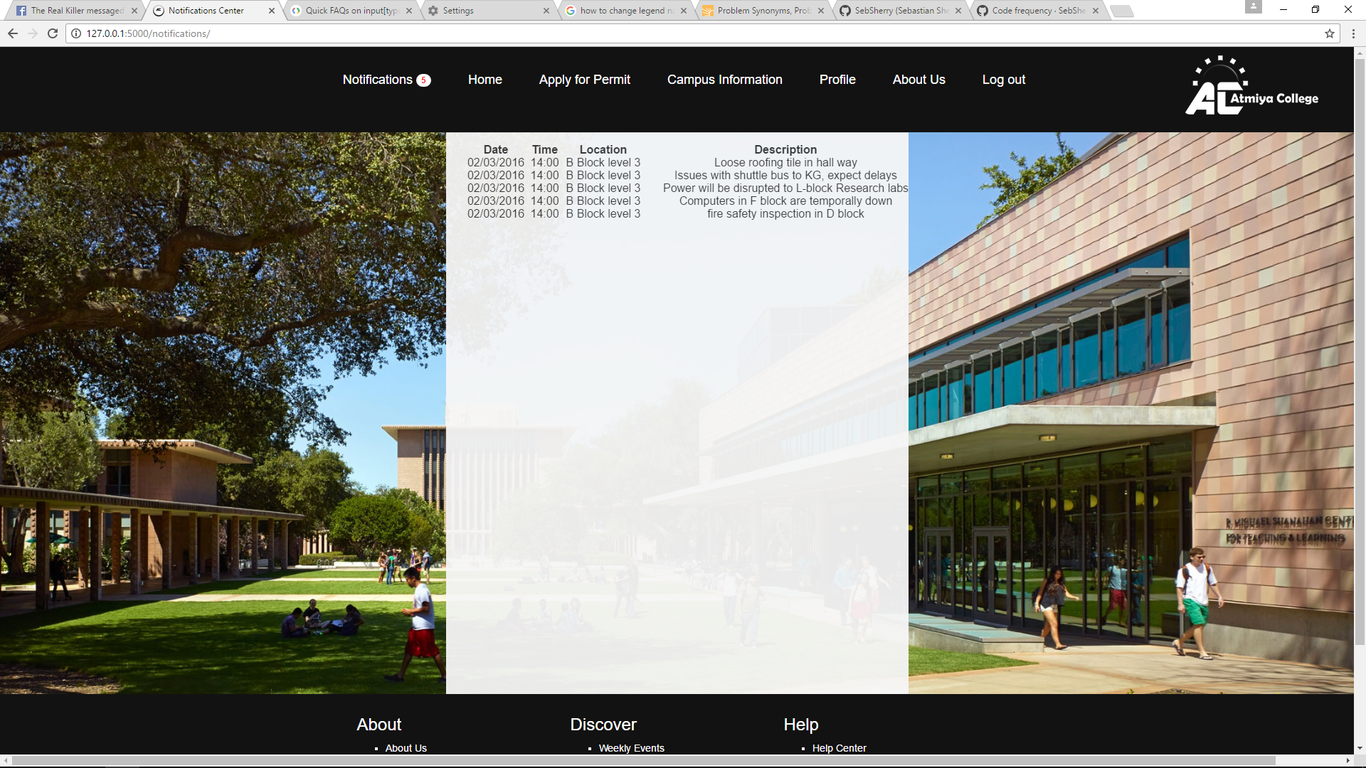

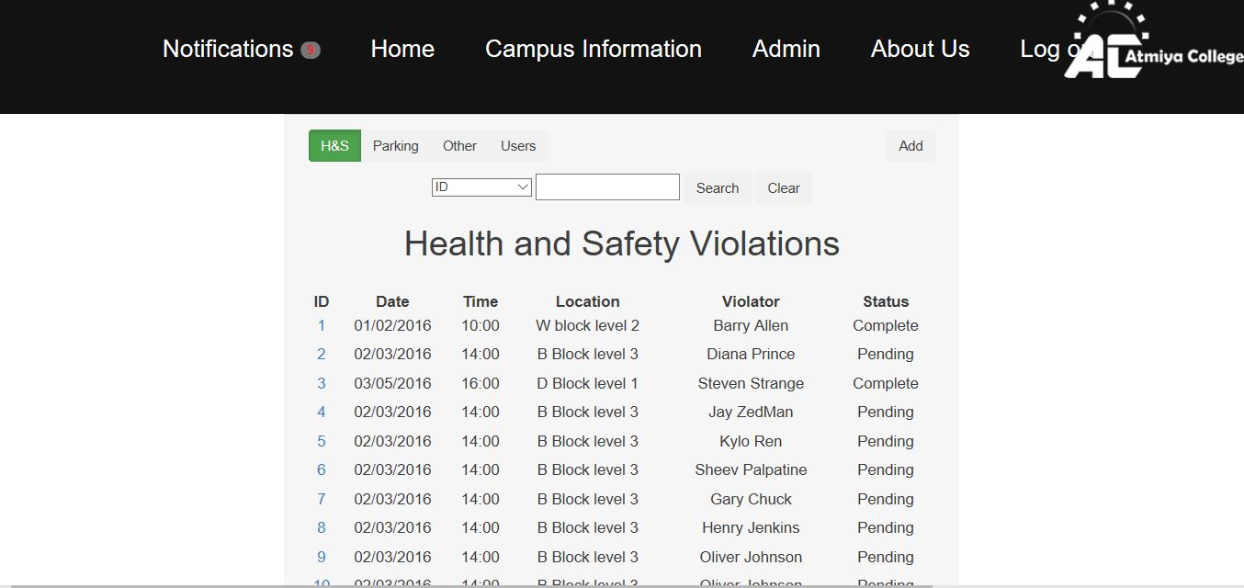

Though this screenshot shows only some of the email functions, all the acceptance criteria were tested and fulfilled. The examples included in the example below include parking updates and overdue fine payment notifications.

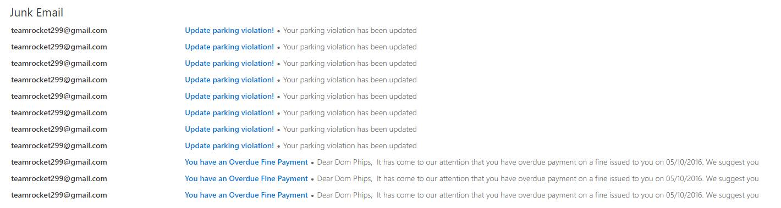

**Story 1: Manual Update**

This story’s acceptance criteria has been met as the applications allows admins to add and update rules into the database, which are then displayed to users upon their next login.

* logged in admins can click on the rules and regulations page and chose to add rules

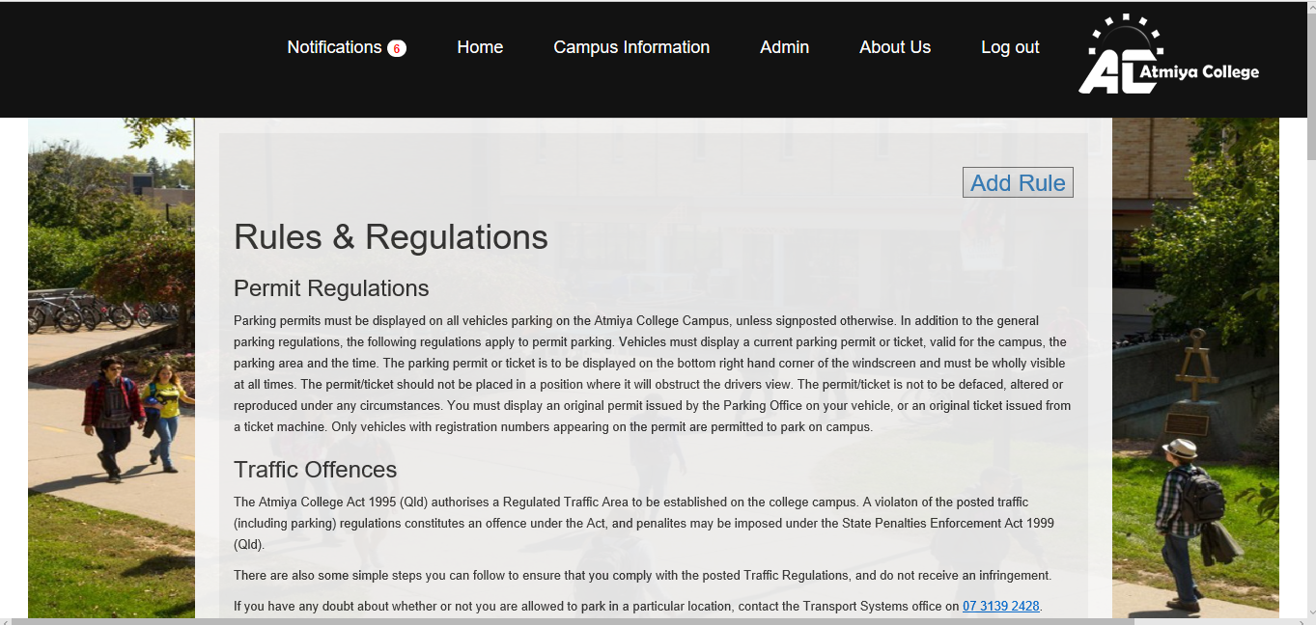

*Admin can fill out the form below and add rules into the database

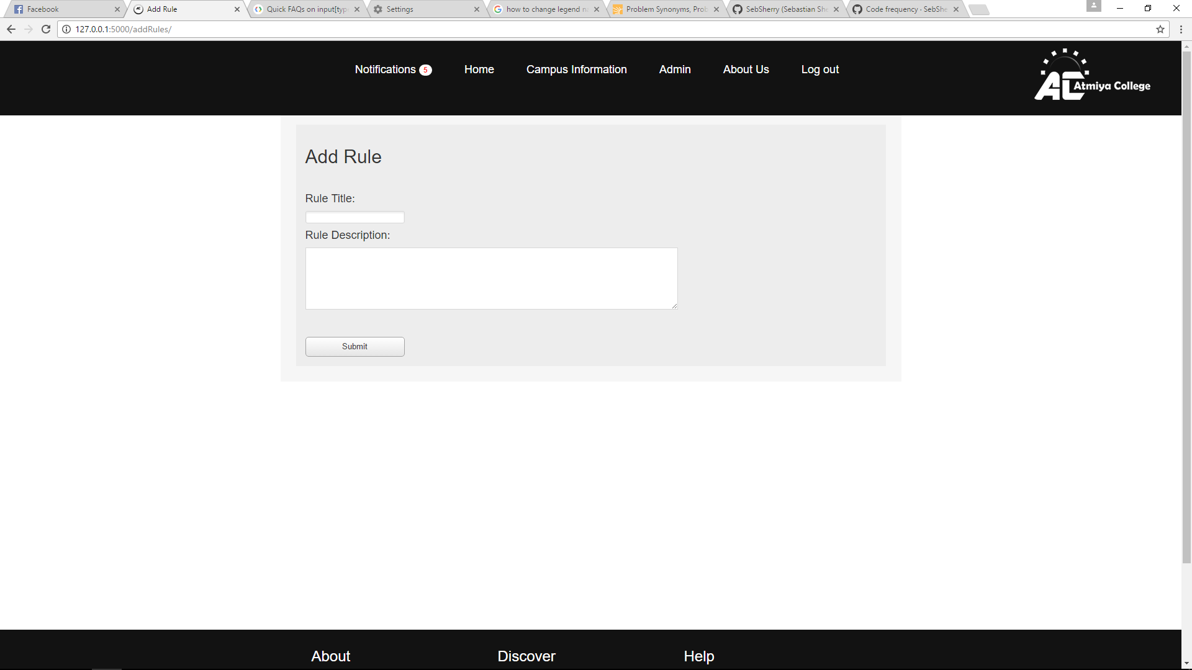

Admins can also update existing rules

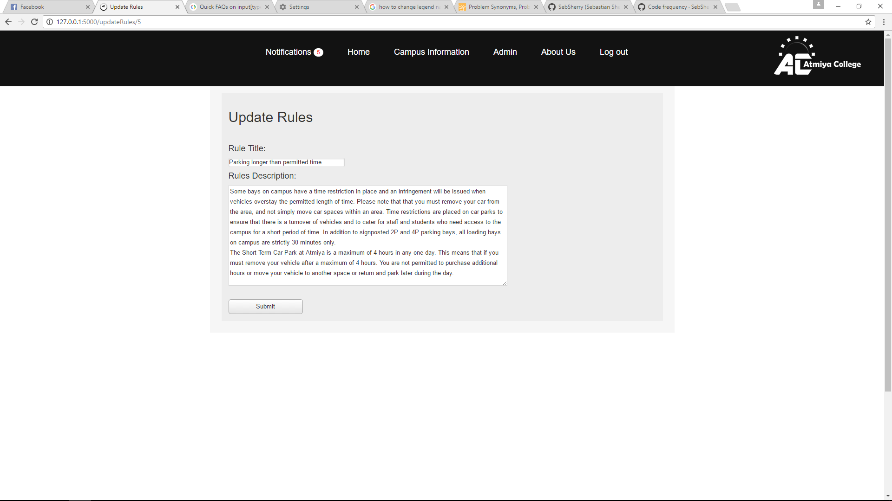

For a demo, I made a handicap rule. After I submitted it took me to the rules page. It worked, and I can update and delete rules I want.

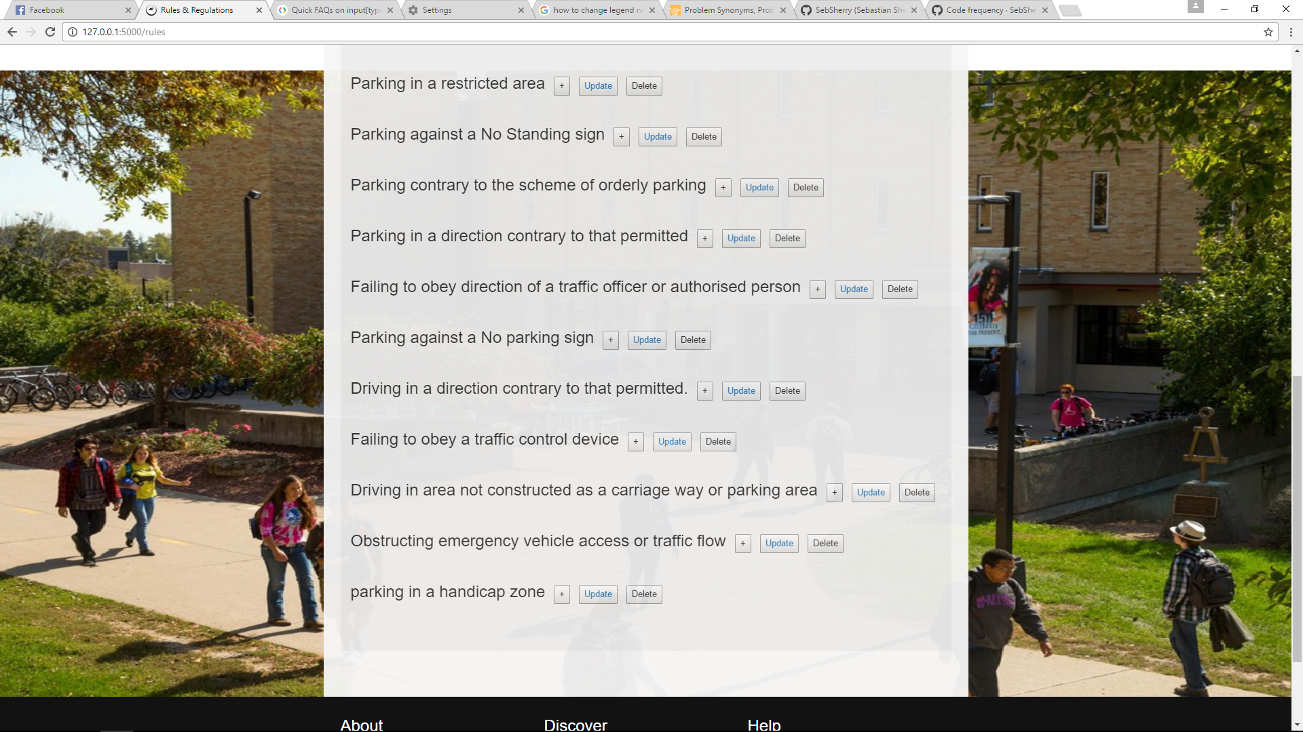

This story exceeds the acceptance criteria as it even has a confirmation box to ensure rules are not accidentally deleted.

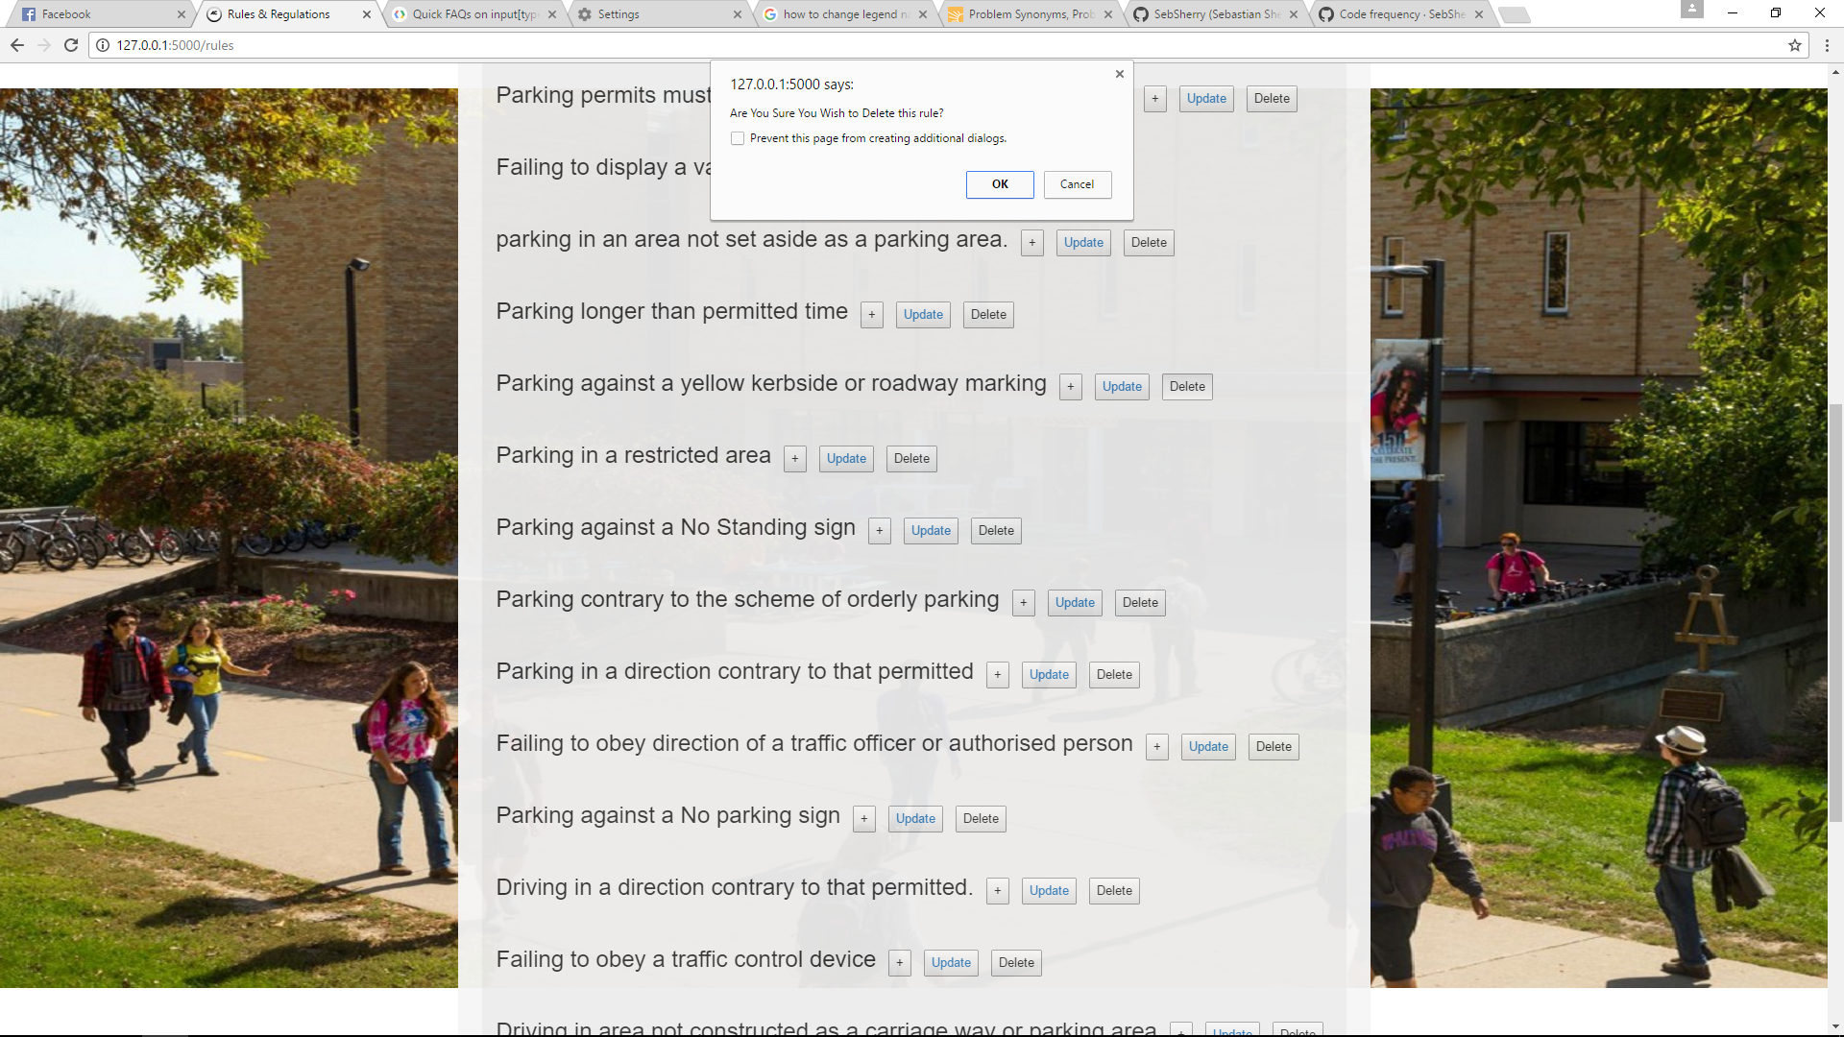

Upon login, the user of the system is notified of whether the rules are updated or any new rules have been added so they are aware of these changes and can avoid penalties.

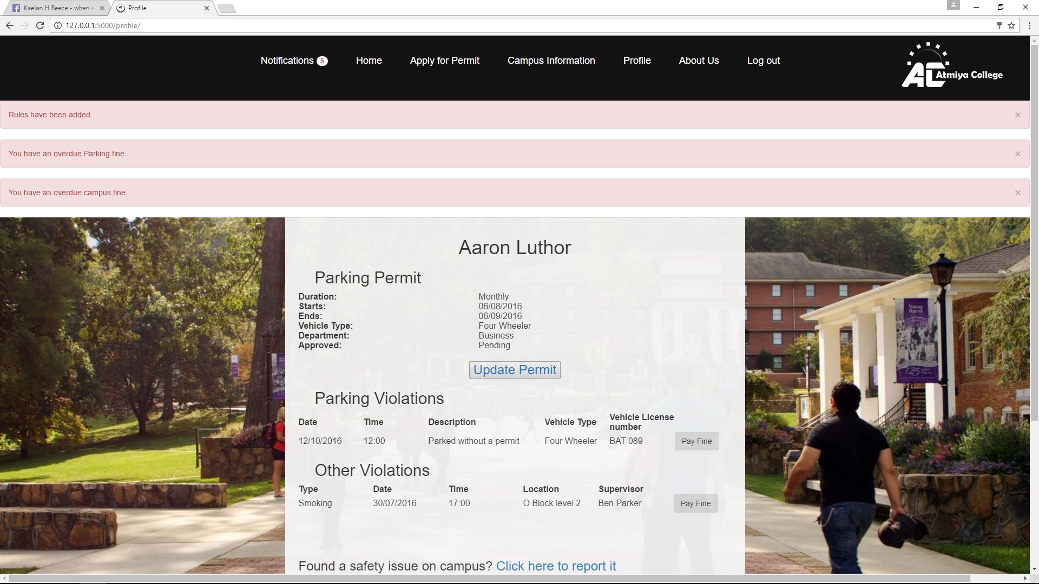

**Story 10: Educating patrol officer**

Patrol staff and admins receive a notification when the rules have been updated or new rules added so they do not submit incorrect violation.

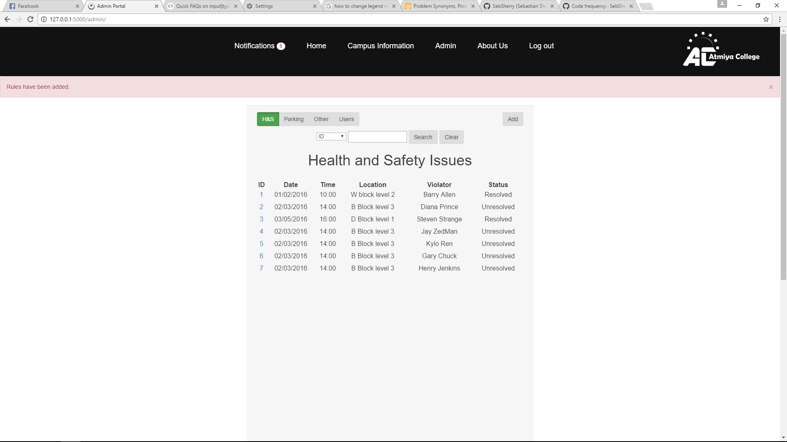

**Story 17: Regular updates**

This story satisfies the acceptance criteria as both permit holders and patrol staff are notified of rule changes that have occurred upon both login and by email. Any visitor to the site can view the rules, regardless of whether they are logged in.

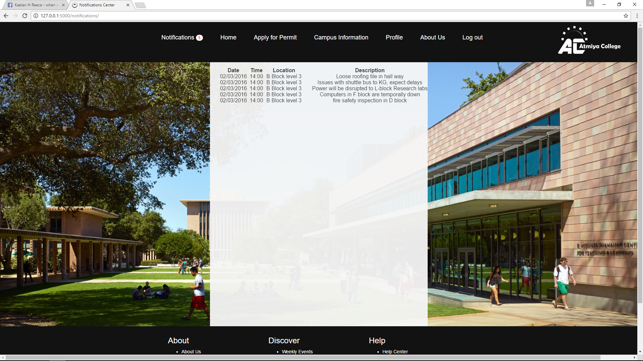

**Story 14: Violation notification**

Acceptance criteria for this story is fulfilled because permit holders are notified when they receive new violations/fines and notified of the violation type. All pertinent details regarding the violation are available to the violator so they know why they are being penalised.

